MD. Shahnawze Ahsan

**Abstract:**

The world around us is getting automated day by day with the advent of technology. Because of tiring the manual labor, automated systems are being favored. As other types of farming , Pigeon farm also can be done using the system to yield more comfortable environment and for more production. In pigeon farming, to protect the fit racing pigeon from losing form temperature in the farm must be above 10 and below 30 degree Celsius, and the humidity kept below 65% . These are the conditions that favor continuing health and known as the Thermo-Neutral zone for the pigeon. In this project we are going to develop a system that will control the lights and blower fan as required temperature and humidity including the desired time. Alongside we also try to implement a password based security system for the farmhouse.

**Introduction:**

Nowadays everything can be controlled and operated automatically, but there are still a few important sectors in our country where automation has not been adopted or not been put to a full-fledged use. One such field is that of pigeon farming. Once people keeps a few pair of pigeon at home as a hobby. But now this pigeon farming is being large and popular day by day. They keeps various kinds of local and foreign breeds at a large area. The existing set-ups primarily are:

• This set-up involves visual inspection of pigeons, turning ON and OFF the temperature controllers. It is time consuming, vulnerable to human error and hence less accurate and unreliable.

• This set-up is a combination of manual supervision and partial automation and is

similar to manual set-up in most respects but it reduces the labour involved in terms of

irrigating the set-up.

This is a sophisticated set-up which is well equipped to react to most of the climatic changes

occurring inside the farmhouse. It works on a feedback system which helps it to respond to the

external stimuli efficiently. Although this set-up overcomes the problems caused due to human

errors it is not completely automated and expensive.

**Literature Review:**

Abdullah Tanveer [3] He proposed a system on Automated Farming Using Microcontroller and Sensors based on 8051 microcontroller. Drishti Kanjilal [4] Who proposed a system including Automatic lighting,

climate control, Fire and smoke detection, Auto door lock, Pre-Set wash timer, Feeder Control and Remote mobile connectivity.

In this project we are going to used AVR microcontroller based automation and security system .

**Project Design**

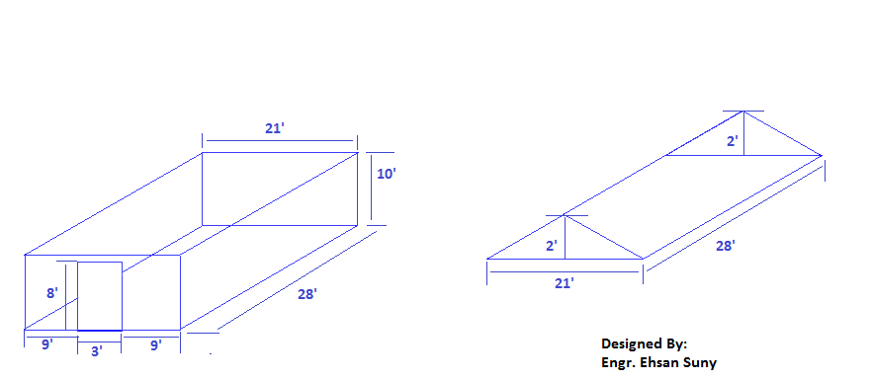

**Fig: Farmhouse design**

**Block Diagram**

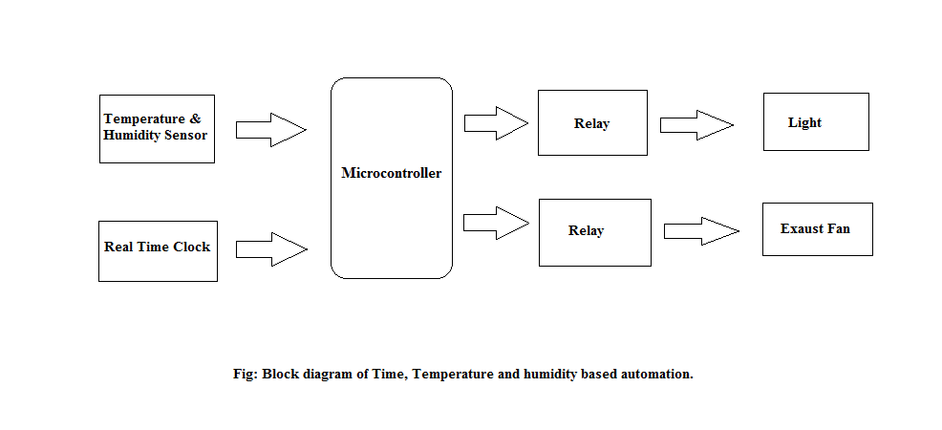

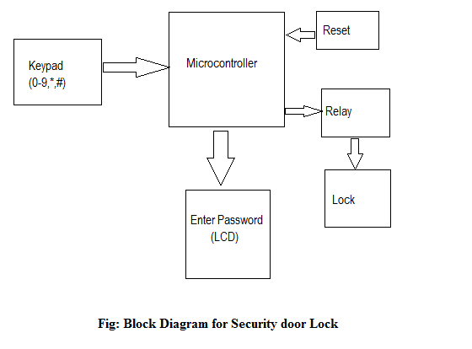

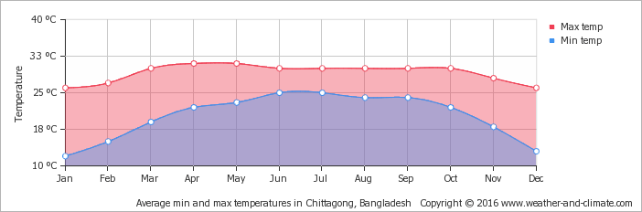

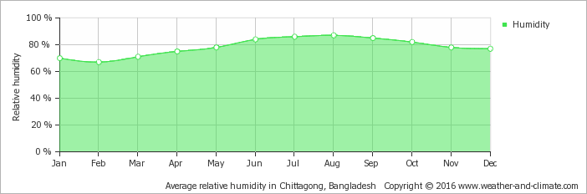

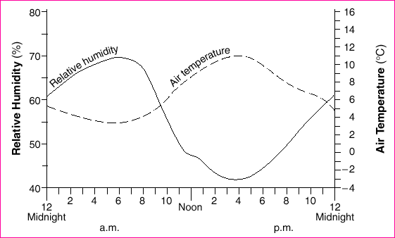

**Flow Chart**

**Implementation**

**Productivity**

**Future Works**

**Conclusion**

**References:**

[3] Abdullah Tanveer “Automated Farming Using Microcontroller and Sensors” International Journal of Scientific Research and Management Studies (IJSRMS) ISSN: 23493371 Volume 2 Issue 1, pg: 21-30 ; http://www.ijsrms.com ©IJSRMS pg. 21

[4] Drishti Kanjilal “Smart Farm:Extending Automation To the Farm Level” INTERNATIONAL JOURNAL OF SCIENTIFIC & TECHNOLOGY RESEARCH VOLUME 3, ISSUE 7, JULY 2014 ISSN 2277-8616 109 IJSTR©2014 ; www.ijstr.org